**ENGELS**

**MISCELLANEOUS INFORMATION**

**THE ALPHABET**

W = dubbel u

X = ex

Z = zed

**DAYS AND MONTHS**

DAYS (Hoofdletter!)

|  |  |
| --- | --- |
| Monday | Tuesday |
| Wednesday | Thursday |
| Friday | Saturday |
| Sunday |  |

MONTHS(Hoofdletter!)

|  |  |
| --- | --- |
| January | February |
| March | April |
| May | June |
| July | August |
| September | October |
| November | December |

SEASONS(Geen hoofdletter!)

|  |  |
| --- | --- |
| winter | summer |
| spring | autumn |

NATIONALITIES (Hoofdletter!)

|  |  |
| --- | --- |
| Belgium | Belgians |
| Flanders | Flemish |
| Wallonia | Walloons |
| Europe | European |

**DATES**

To announce the date: It’s

It’s April 1(st)

Engels: 5 October 2013 – 5/10/2013

Amerikaans: October 5, 2013 – 10/05/2013

NUMBERS

18 = eighteen

100 = one hundred

FRACTIONS

1/8 = one over eight

¾ = three quarters

1/3 = one third

1/2= one over two / a halve

Complex fractions x/y = x over y

DECIMALS

0.125 = point one two five

0.33 = point dubble three

0.001 point not not one

!!! WHEN TALKING ABOUT MONEY WE USE NORMAL NUMBERS !!!

EUR 1.50 = 1 euro fifty cents

Zero exactly 0

Nought decimals

Oh telephone numbers

Nil sports

Love tennis

ABBREVIATION AND NUMBERS

24/7: Every day all day

3-D: length, width, height , depth

911: nine one one

LINEAR MEASURES

|  |  |  |  |
| --- | --- | --- | --- |
| “ | in | Inch | 2.54 mm |
| ‘ | ft | Foot | 30 cm |
|  | yd | Yard | 0.91m |
|  | ml | Mile | 1.6 km |

How do you say it?

Measuring 9 by 8

Going 30 miles per hour

MATHEMATICAL EXPRESSIONS

|  |  |
| --- | --- |
| Optellen | Add |
| Aftrekken | Subtract |
| Vermenigvuldigen | Multiply |
| Delen | Divide |
| + | Plus |
| - | Minus |
| +- | About |
| X | Times |
| % | Divide by |
| = | Is equal to |
| < | Smaller then |
| > | Greater then |
| % | Percentage |
| Π | Pi |
| $$√$$ | Square root |
| X² | Squared |
| X³ | Cubed |
| $$x^{y}$$ | X tot he power of y |
| I/R | I over R |
| Km² | Square kilometres |
| ° | Degrees |
| 11:1 | Eleven to one |
| Area | Oppervlakte |
| Circumreference | Omtrek |
| Radius | straal |

MONEY

UK

1p = a/one penny

100p = 100 pence = 1 pound

£1 = one pound

COMPUTER SYMBOLS

|  |  |
| --- | --- |
| # | Hashtag |
| $ | Dollarsign |
| & | Ampersand |
| - | Hyphen |
| ( | Open bracket |
| ) | Closed bracket |
| @ | At |
| ; | Semicolon |
| * | Asterisk |
| : | Colon |
| , | Comma |
| . | Point, dot |
| ? | Quotation mark |
| / | Forward slash |
| { | Open curly bracket |
| } | Closed curly bracket |
| [ | Open square bracket |
| ] | Closed square bracket |
| _ | Underscore |
| | | Pipe |
| \ | Back slash |
| ‘ | Quotation mark/appostrophe |
| ! | Exclamation mark |
| ^ | Wedge/het/circumflex |

ABBREVIATIONS

|  |  |
| --- | --- |
| a.m. | Ante meridiem |
| p.m. | Post meridiem |
| i.e. | It est |
| e.g. | Exampli gravitas |
| CV | Curriculum Vitae |
| Encl. | Enclosed |
| Asap | As soon as possible |
| Ref. | Reference |
| Etc | Et cetera |
| PS | Post scriptum |
| Vs | Versus |
| MP | Member of parliament |
| MEP | Member of European parliament |
| Excl. | Exclusive |
| Mr | Mister |
| Mrs | Misses (gehuwde vrouw) |
| Miss | Juffrouw (ongehuwde vrouw) |
| VAT | Venue added tax |

TELLING THE TIME

It is x minutes pas/to y

ASKING THE TIME

What time is it?

What’s the time?

Have you got the time? (informal)

Could you tell me the time? (more formal)

PUNCTUATION

Improves readability, check p.132-138

|  |  |
| --- | --- |
| Apostrophe | ‘ |
| Comma | , |
| Colon | : |
| Quotation marks | “ |
| Semicolon | ; |
| A dash | - |

BUSINESS WRITING: LETTERS AND EMAILS

When writing a letter or an email, ask yourself the following questions:

* Who am I writing to?
* What is my relationship with the recipient
* Why am I writing? What am I hoping to achieve?
* What action do I expect from the recipient?

Informal vs formal

|  |  |
| --- | --- |
| Informal | Formal |
| What do you need | Please let us know your requirements |
| Thanks for the email of 12 sep | Thank you for your email received 12 Sep… |
| Sorry, I can’t make it | I am afraid I will not be able to attend |
| I’m sorry to tell you that … | We regret to advise you that …. |
| I promise… | I can assure you that … |
| Could you … ? | I was wondering if you could … |
| You haven’t … | We note from our records that you have not |
| Don’t forget … | We would like to remind you that … |
| I need to … | It is necessary for me to … |
| Shall I … ? | Would you like me to … ? |
| But .. / Also … / So … | However …/In addition … / Therefore … |
| Please could you … | I would be grateful if you could … |
| I’m sorry for … | Please accept our apologies for … |
| Re | With regard to … / With reference to … |
| See you next week | I look forward to meeting you next week. |
| Help | Assistence |
| Because of | Due to |
| Ask | Enquire |
| More | Further |
| Tell | Inform |
| Facts | Information |
| Get | Obtain/Receive |
| Job | Occupation |
| Have | Possess |
| Give | Provide |
| Fix | Repair |
| Ask for | Request |
| Needs | Requirements |
| Book | Reserve |
| Check/prove | verify |

USEFULL EXPRESSIONS AND VOCABULARY

Salutations

Wanneer je de naam van een persoon niet kent:

* Dear Sir
  + als je weet dat het een man is
* Dear Madam
  + Als je weet dat het een vrouw is
* Dear Sir or Madam
  + de beste keuze

Wanneer je de naam van een persoon kent:

* Dear Mr Black
  + Mr is een man, gehuwd of ongehuwd
* Dear Ms Brown
  + Ms is de titel voor een vrouw, gehuwd of ongehuwd
* Dear Miss Brown
  + Miss is de titel voor een ongehuwde vrouw
* Dear Mrs Brown
  + Mrs is de titel voor een gehuwde vrouw

Complimentary closes

Wanneer je de naam van een persoon niet kent:

* Yours faithfully

Wanneer je de naam van een persoon kent:

* Yours sincerely

OPENINGS AND CLOSINGS

Altijd je brief openen en afsluiten op een persoonlijke en beleefde manier. Zie P145 voor voorbeelden.

SUBJECT LINES

Keep your subject line simple and focused; be clear and specific

PHRASAL VERBS, IDIOMS AND COLLOCATIONS

Idioms

* An idiom is a phrase which means something different from the meanings of the separate words from which it is formed
  + Kick the bucket -> to die

Collocation

* Habitual combination of words which sounds natural
  + Strong coffee

Phrasal verbs

* Group of words that acts like a ver band consists usually of a verb with an adverb and/or a preposition
  + Set off
  + Put up with

**LANGUAGE WORK**

**ASKING QUESTIONS**

YES-NO QUESTIONS

Form:   
auxiliary verb (be, do or have) + subject + main verb  
or  
modal verb + subject + main verb

Examples:

* Do you work full-time?
* Has the manager told you?
* Can you see him?

We use negative yes-no questions to check or confirm something we believe or expect tob e the case, or when we consider that something is the best thing to do

* Shouldn’t we be leaving?

Rather than simply asking ‘yes’ or ‘no’ to yes-no questions we can also answer using the auxilery from the questions

* Do you work full time? - Yes, I do/No, I don’t

WH QUESTIONS

Questions that begin with

* What
* When
* Where
* Who
* Whom
* Which
* Whose
* Why
* How

We use them to ask for information, the answer cannot be yes or no

Form:  
wh + auxilery verb (be, do or have) + subject + main verb  
or  
wh + modal verb + subject + main verb

Examples:

* When are you starting your new job?
* Who’s taking you home?

QUESTION TAGS

* They love horses, don’t they?
* I am your best friend, aren’t I?
* He used to visit often, didn’t he?
* He ought to go home, shouldn’t he?

COMPARATVES AND SUPERLATIVES

One-syllable adjectives:

Comparative: adjective + er -> old, older

Superlative: adjective + est -> old, oldest

Two-syllable adjectives:

adjective -y + ier/iest | adjective + er/est | more/most + adjective

* Busy, busier, busiest, clever, cleverer, cleverest, more careful, most careful

Longer adjectives:

More/most + adjective

More expensive, most expensive

Vergelijkingen van 2 dingen/personen

* The bigger of the 2 (comparatief)

Onregelmatigheden

|  |  |  |
| --- | --- | --- |
| Adjective | Comparative | Superlative |
| Good | Better | Best |
| Bad | Worse | Worst |
| Old | Older/elder (fam) | Oldest/eldest (fam) |
| Far | Further/farthest | Furthest/farthest |

ACTIVE TENSES

* SIMPLE PERSENT (Tegenwoordige tijd)
  + General truth
  + Habitual/repeated actions
  + Time table future
  + Non-action verbs: senses, mental activity, …
  + Examples
    - I brush my teeth every morning
    - She owns a flat
    - The train leaves at 9 o’clock
* PRESENT CONTINUOUS (Tegenwoordige tijd ?)
  + Going on at the moment the words are spoken
  + Actions planned in the near future: arrangements have been made (arranged future)
  + To express irritation, annoyance
  + Examples
    - Stephen is always nagging his wife
    - She’s getting married
    - That man is taking a photograph of you

PAST TENSES

* SIMPLE PAST (Verleden tijd)
  + Actions completed in the past at a definite time
  + Habitual/repeated actions in the past
  + Examples
    - John Lennon died in 1980
    - We once owned a caravan
    - When I was a child, I always visited my grandparents on Sunday
* PAST CONTINUOUS (Verleden tijd?)
  + Duration (at a given time) in the past
  + To express irritation about past actions
  + Examples
    - At 6 a.m. I was still sleeping
    - Anne was forever poking her nose into my affairs

PRESENT PERFECT TENSES

* SIMPLE PRESENT PERFECT
  + Actions in the past, no time indication:present result of past action
  + With JUST and ALREADY: for actions/situations that are over
  + With FOR (duration stressed) and SINCE (starting point stressed):action that began in the past, is still going on no wand may continue in the future
  + Examples
    - Bob Marley has been a star for years
    - He has sold his car
    - Her song has been a number one hit since July
    - I have already been to see her today
* SIMPLE PERFECT CONTINUOUS
  + Actions beginning in the past, still going on or just finished. Stress on duration
  + Examples
    - Diana has been living in London since she was born

PAST PERFECT TENSES

* SIMPLE PAST PERFECT
  + Past action completed before another past action began
  + Examples
    - He had already called her before I could warn her
* PAST PERFECT CONTINUOUS
  + Duration up to a certain point in the past
    - They had been seeing each other for months during the nineties

FUTURE TENSES

* SIMPLE FUTURE
  + Uncoloured future: It is bound to happen
  + Coloured future : to express strong determination/desire
  + To express a spontanious decision
  + To express willingness
  + To express unwillingness
  + …
  + Examples:
    - He will be 21 next month
    - I will succeed this year
    - I’ll pay fort he tickets by credit card
    - He’ll carry your bag for you
* FUTURE CONTINUOUS
  + For actions which will be going on at a certain time in the future
  + To ask very polite questions about future activities
  + To made deductions about what is going on now
  + To indicate long-term arrangements
  + Examples
    - It’s 6 p.m. now. He’s having dinner. Tomorrow at 6 p.m. he’ll be having dinner too
    - Where will you be having dinner?
    - I can’t find her, she will be doing the washing-up
    - They will be travelling to Japan at the end of the year
* INTENTIONAL FUTURE (to be going to + inf)
  + To express intention/plan or strong probability
    - I’m going to watch TV tonight
* FUTURE PERFECT(will have + past participle)
  + For an action which at a given future time will be completed
  + Examples:
    - By the end of the year they will have forgotten everything

MODAL VERBS: ABILITY/POSSIBILITY/PERMISSION

ABILITY

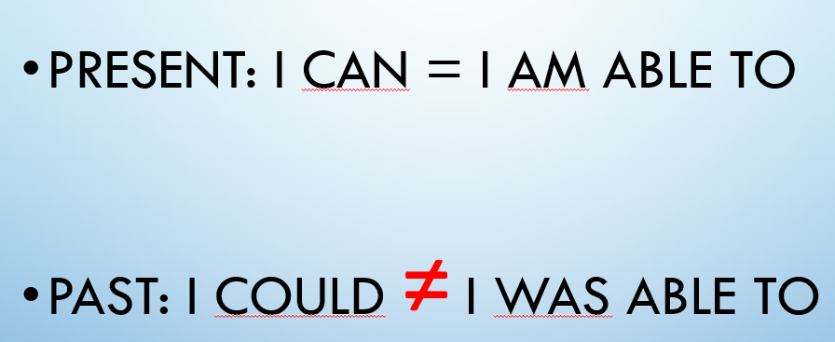

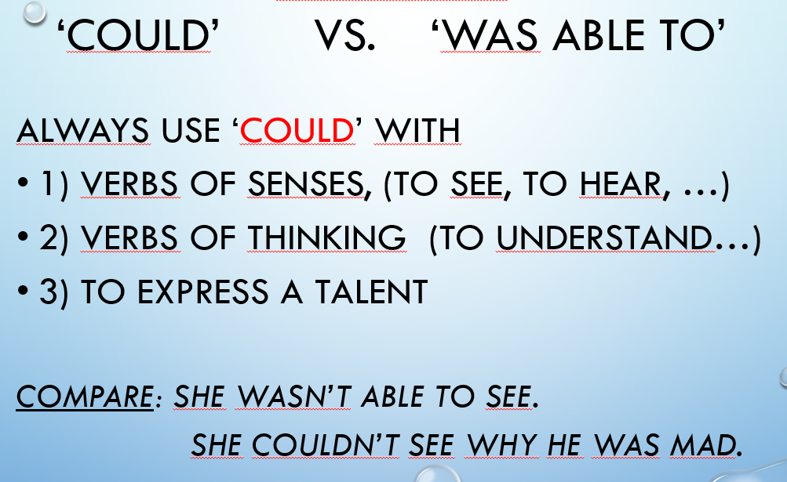

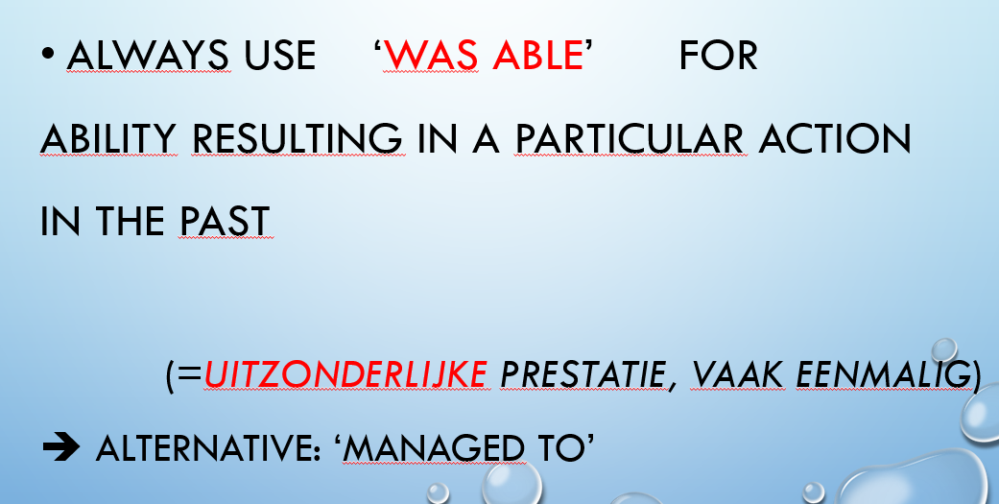

PERMISSION

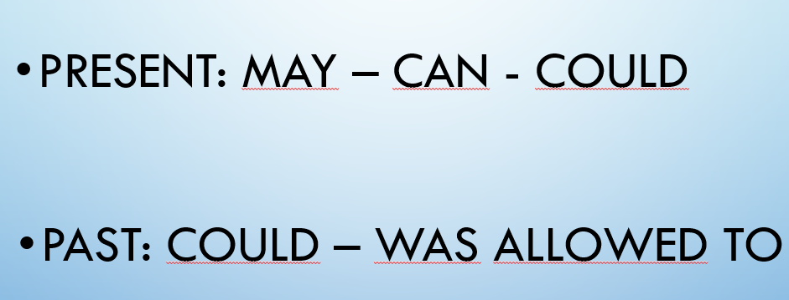

POSSIBILITY

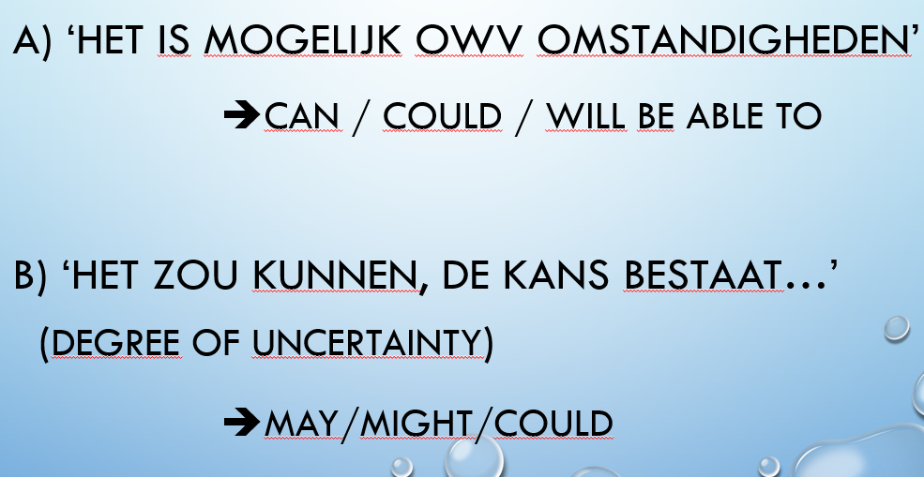

IRREGULAR VERS

|  |  |  |
| --- | --- | --- |
| To+infinitive | Simple past | Past participle |
| Be | Was/were | Been |
| Bear | Bore | Borne |
| Beat | Beat | Beat |
| Become | Became | Become |
| Begin | Began | Begun |
| Bent | Bent | Bent |
| Bet | Bet | Bet |
| Bind | Bound | Bound |
| Bite | Bit | Bitten |
| Blow | Blew | Blown |
| Break | Broke | Broken |
| Bring | Brought | Broight |
| Build | Built | Built |
| Burst | Burst | Burst |
| Buy | Bought | Bought |
| Catch | Caught | Caught |
| Choose | Chose | Chosen |
| Come | Came | Come |
| Cost | Cost | Cost |
| Cut | Cut | Cut |
| Deal | Dealt | Dealt |
| Dig | Dug | Dug |
| Do | Did | Done |
| Draw | Drew | Drawn |
| Drink | Drank | Drunk |
| Drive | Drove | Driven |
| Eat | Ate | Eaten |
| Fall | Fell | Fallen |
| Feed | Fed | Fed |
| Feel | Felt | Felt |
| Fight | Fought | Fought |
| Find | Found | Found |
| Fly | Flew | Flown |
| Forbid | Forbade | Forbidden |
| Forget | Forgot | Forgotten |
| Forgive | Forgave | Forgiven |
| Freeze | Froze | Frozen |
| Get | Got | Got |
| Give | Gave | Given |
| Go | Went | Gone |
| Grow | Grew | Grown |
| Hang | Hung | Hung |
| Have | Had | Had |
| Hear | Heard | Heard |
| Hide | Hid | Hidden |
| Hit | Hit | Hit |
| Hit | Hit | Git |
| Hold | Held | Held |
| Hurt | Hurt | Hurt |
| Keep | Kept | Kept |
| Know | Knew | Known |
| Lay | Laid | Laid |
| Lead | Led | Led |
| Leave | Left | Left |
| Lend | Lent | Lent |
| Let | Let | Let |
| Lie | Lay | Lain |
| Light | Lit | Lit |
| Lose | Lost | Lost |
| Make | Made | Made |
| Mean | Meant | Meant |
| Meet | Met | Met |
| Pay | Paid | Paid |
| Put | Put | Put |
| Read | Read | Read |
| Ride | Rode | Ridden |
| Ring | Rang | Rung |
| Rise | Rose | Risen |
| Run | Ran | Run |
| Say | Said | Said |
| See | Saw | Seen |
| Seek | Sought | Sought |
| Sell | Sold | Sold |
| Send | Sent | Sent |
| Set | Set | Set |
| Sew | Sewed | Sewn/sewed |
| Shake | Shook | Shaken |
| Shine | Shone | Shone |
| Shoot | Shot | Shot |
| Show | Showed | Shown |
| Shrink | Shrank | Shrunk |
| Shut | Shut | Shut |
| Sing | Sang | Sung |
| Sit | Sat | Sat |
| Sleep | Slept | Slept |
| Speak | Spoke | Spoken |
| Spend | Spent | Spent |
| Split | Split | Split |
| Spread | Spread | Spread |
| Spring | Sprang | Sprung |
| Stand | Stood | Stood |
| Steal | Stole | Stolen |
| Stick | Stuck | Stuck |
| Sting | Stung | Stung |
| Stink | Stank | Stunk |
| Strike | Struck | Struck |
| Swear | Swore | Sworn |
| Sweep | Swept | Swept |
| Swim | Swam | Swum |
| Swing | Swung | Swung |
| Take | Took | Taken |
| Teach | Taught | Taught |
| Tear | Tore | Torn |
| Tell | Told | Told |
| Think | Thought | Thought |
| Throw | Threw | Thrown |
| Understand | Understood | Understood |
| Wake | Woke | Woken |
| Wear | Wore | Worn |
| Win | Won | Won |
| Write | Wrote | Written |

**Woordenschat Engels: Unit 4 – 7 – 8**

|  |  |
| --- | --- |
| **Unit 4** |  |
| **Pages 40-41** |  |
| acoustic (adj) | akoestisch |
| adrenaline (n) | adrenaline |
| charm (v) | charmeren |
| epiphany (n) | openbaring |
| extremity (n) | handen en voeten |
| fight or flight response (n) | vlucht- of vechtreactie |
| finalist (n) | finalist |
| graphic designer (n) | grafisch ontwerper |
| heart rate (n) | hartslag |
| onstage (adv) | op het podium |
| open mic (n) | open microfoon |
| physiologically (adv) | fysiologisch gezien |
| quirky (adj) | eigenzinnig |
| relate to (something) (phr v) | verband houdend met (iets) |
| rush (n) | stoot |
| stage fright (n) | podiumvrees |
| sympathetic nervous system (n) | orthosympathisch zenuwstelsel |
| tool (n) | instrument |
| unconscious (adj) | onbewust |
| wave of anxiety (phr) | golf van ongerustheid |
| **Pages 42-43** |  |
| conducive (adj) | bevorderlijk |
| confront (v) | overwinnen |
| convulse (v) | stuiptrekken |
| digestion (n) | vertering |
| dilate (v) | groter/wijder worden |
| embarrassed | beschaamd, in verlegenheid gebracht |
| emotive (adj) | emotief |
| fess up (v) | toegeven, opbiechten |
| image (n) | beeld |
| kick in (phr v) | toeslaan |
| nausea (n) | misselijkheid |
| react (v) | reageren |
| realization (n) | besef |
| sarcastic (adj) | sarcastisch |
| shake (v) | afschudden |
| a **sip** of water (n) | een slokje water |
| sure enough (phr) | inderdaad |
| **Pages 44-45** |  |
| absorption (n) | absorptie |
| equivalent (n) | equivalent |
| information overload (n) | informatieoverbelasting |
| manageable (adj) | hanteerbaar |
| subscriber (n) | abonnee |
| time-consuming (adj) | tijdrovend |
| transfer rate (n) | overdrachtssnelheid |
| **Pages 46-47** |  |
| address an issue (phr) | een probleem aanpakken |
| a brick wall (phr) | een obstakel |
| come up against (something) (phr v) | stuiten op (iets) |
| exception | uitzondering |
| flavour (n) | smaak |
| get a cool reception (phr) | een koel onthaal krijgen |
| handmade (adj) | handgemaakt |
| make a splash (phr) | inslaan als een hit |
| market (n) | markt |
| meet with opposition (phr) | op tegenstand stuiten |
| obstacle (n) | hindernis |
| occasional (adj) | af en toe/occasioneel |
| one man’s meat is another man’s poison (phr) | smaken verschillen |
| raising awareness (phr) | het bewustzijn doen groeien; mensen bewust maken van iets |
| relocate (v) | verhuizen |
| sell like hotcakes (phr) | verkopen als warme broodjes |
| slogan (n) | slogan |
| suppose (v) | veronderstellen |
| to each his own (phr) | ieder voor zich |
| voice concern (phr) | bezorgdheid uiten |

|  |  |
| --- | --- |
| **Unit 7** |  |
| **Pages 74-75** |  |
| airspace (n) | luchtruim |
| billow (v) | opbollen |
| bronze (n) | brons |
| bundle (v) | samenbundelen |
| casting (n) | gietwerk |
| ephemeral (adj) | vergankelijk |
| fabric (n) | stof |
| fastening (n) | sluiting |
| idiosyncratic (adj) | eigenzinnig |
| inviting (adj) | uitnodigend |
| knot (n) | knoop |
| lace (n) | kant |
| mound (n) | hoop |
| natural fibre (n) | natuurlijke vezel |
| pay tribute to (something) (phr) | eer betonen aan (iets) |
| point of focus (n) | focuspunt |
| reshape (v) | opnieuw vorm geven |
| volumetric (adj) | volumetrisch |
| **Pages 76-77** |  |
| accomplishment (n) | prestatie |
| adapt (v) | wijzigen |
| authentic (adj) | authentiek |
| bland (adj) | onbeduidend |
| craftsperson (n) | vakmens |
| display (v) | weergeven, vertonen |
| division (n) | verdeling |
| firm (adj) | stevig, vast |
| mesmerized (adj) | gebiologeerd |
| natural disaster (n) | natuurramp |
| ripple (v) | rimpelen |
| sculptor (n) | beeldhouwer, artiest die sculpturen creëert |
| shift (v) | verschuiven |
| waterfront (n) | waterkant |
| **Pages 78-79** |  |
| (somebody’s) mind wander (phr) | (iemands) gedachten de vrije loop laten |
| alter (v) | iets veranderen |
| commute (v) | pendelen |
| daydream (v) | dagdromen |
| decrease (v) | afnemen, dalen |
| drawback (n) | keerzijde |
| increase (v) | toenemen, stijgen |
| routine (adj) | routinematig |
| test subject (n) | proefpersoon |
| **Pages 80-81** |  |
| be in two minds about (something) (phr) | twijfelen over (iets) |
| bear (something) in mind (phr) | rekening houden met (iets) |
| blow your mind (phr) | doet je versteld staan |
| distracted (adj) | afgeleid zijn, uit de concentratie gehaald worden |
| ease your mind (phr) | je geruststellen |
| experimental (adj) | experimenteel |
| give (somebody) peace of mind (phr) | (iemand) geruststellen |
| have something on your mind (phr) | zich zorgen maken over iets |
| keep an open mind (about something) (phr) | open van geest zijn (over iets) |
| measurable (adj) | meetbaar |
| outcome (n) | resultaten |
| put your mind to (something) (phr) | je gedachten op (iets) zetten |
| research (n) | onderzoek |
| see (something) in your mind’s eye (phr) | zich (iets) voor de geest halen |
| strengthen (v) | iets versterken |
| suspicious (adj) | verdacht |
| visualize (v) | visualiseren |
| **pages 82-83** |  |
| abandon (v) | iemand/iets verlaten, in de steek laten |
| alien (adj) | vreemd |
| allegedly (adv) | zogenaamd |
| artefact (n) | artifact |
| by all accounts (phr) | zonder meer |
| forest fire (n) | bosbrand |
| magnetic (adj) | magnetisch |
| occurrence (n) | voorval |
| quote (v) | citeren |
| reportedly (adv) | naar verluidt |
| seemingly (adv) | schijnbaar |
| speculation (n) | speculatie |
| supposedly (adv) | vermeend |

|  |  |
| --- | --- |
| **Unit 8** |  |
| **Pages 84-85** |  |
| absorb information (phr) | informatie absorberen |
| assign (v) | toewijzen |
| assumption (n) | veronderstelling |
| assume (v) | veronderstellen |
| collaboration (n) | samenwerking |
| continually (adv)- | voortdurend |
| executive admin (n) | uitvoerend bestuur |
| facilitation (n) | ondersteuning |
| innovative (adj) | innovatief |
| iterative (adj) | herhalend |
| kindergartener (n) | kleuter |
| practitioner (n) | beoefenaar |
| skilful (adj) | vakkundig |
| **Pages 86-87** |  |
| assemble (v) | monteren |
| cash prize (n) | prijs in cash geld |
| high stakes (n) | met hoge inzet |
| high-stakes (**adj**) (decision) | (beslissing) met hoge inzet |
| jockey for power (phr) | elkaar de loef afsteken voor macht, wedijveren, met de ellebogen werken |
| orient (v) | zich concentreren |
| participant (n) | deelnemer |
| significance (n) | betekenis |
| sketch (v) | schetsen |
| trial and error (phr) | Vallen en opstaan |
| up the ante (phr) | de lat wat hoger leggen |
| **Pages 88-89** |  |
| (be) the consequence of (something) (phr) | het gevolg (zijn) van (iets) |
| acute (adj) | acuut |
| anxiety (n) | angst |
| arise from (something) (v) | voortvloeien uit (iets) |
| bring (something) about (phr v) | (iets) tot stand brengen |
| foster (v) | versterken |
| give rise to (something) (phr) | aanleiding geven tot (iets) |
| kill (stop something) (v) | doden (iets een halt toeroepen) |
| lack (n) | tekort, gebrek aan |
| neck strain (n) | nekbelasting |
| pull a ‘sickie’ (phr) | zich ziek melden |
| recurring (adj) | terugkerend |
| repetitive strain injury (n) | letsel door herhaalde inspanning |
| **Pages 90-91** |  |
| accomplish (v) (tasks) | (taken) vervullen, volbrengen |
| anticipate (v) | anticiperen |
| bond (v) | banden aanhalen |
| do your fair share of (something) (phr) | een eerlijke bijdrage leveren aan (iets) |
| enhance (v) | verbeteren |
| feel a part of (something) (phr) | zich deel voelen van (iets) |
| go the extra mile (phr) | een extra inspanning leveren |
| have a sense of belonging (phr) | het gevoel hebben erbij te horen |
| motivate (v) | motiveren |
| pull your weight (phr) | je gewicht in de schaal leggen |
| resolve (v) (conflicts) | (conflicten) oplossen |
| resentment (v) | afkeer |
| share the load (phr) | samen de last dragen |
| team player (n) | teamspeler |
| teambuilding (n) | teambuilding |
| the mood lightened (phr) | de sfeer klaarde op, de stemming werd verlicht |
| **Pages 92-93** |  |
| as a consequence (phr) | bijgevolg |
| coordination (n) | coördinatie |
| debriefing (n) | debriefing |
| deliver (v) | leveren |
| expertise (n) | expertise |
| feature (v) | voorkomen, ergens op verschijnen |
| host (v) | organiseren |
| invite (ask officially) (v) | uitnodigen (officieel vragen) |
| jump in (phr v) | onderbreken |
| leadership (n) | leiderschap |
| lose money (phr) | geld verliezen |
| project manager (n) | projectmanager |
| signal (v) | wijzen op |
| take the time to (do something) (phr) | de tijd nemen om (iets te doen) |
| teamwork (n) | teamwork |

**ENGELS: HIGHLIGHTES VOCABULARY**

**By day**, he was an average office clerk, but **by night** he was a crime-fighting super hero.

He was **struggling** to make his business a success.

The airline is **struggling** **with** high costs.

We were **charmed** by the friendliness of the local people.

I like his **quirky** sense of humour.

An **acoustic** guitar

The concert was recorded in a church that is famous for its **acoustics**.

Police arrested several men, who were later **released**.

A version of the game for Mac computers will be **released** in February.

He struggled to **overcome** his shyness.

Charles was **overcome** with grief.

Her worst **fear** was never seeing her children again.

**Turn something to your own advantage**

Professionals need to be aware of such things and **turn** them **to** **good** **advantage**.

a study of the **physiology** of whales

**physiological**

an **open mic** evening for aspiring comedians (also **open mike**)

The **sympathetic nervous system** is a part of the autonomic nervous system.

**Adrenalin/Adrenaline**

The **adrenalin rush** of the entire evening made him declare his love.

There’s nothing like a good horror film to **get the adrenalin going.**

The committee was uncomfortable about the **extremity** of the proposal.

After his expedition to the North Pole he came back with frozen **extremities**. (usually plural)

He had a painful **epiphany** about the absurdity of the job and quit.

‘**Epiphany’** is a Christian holy day on January 6th that celebrates the day when the Three Kings came to see the baby Jesus.

The activities are designed to **stimulate** classroom discussions.

The children were filled with **excitement** at the thought of visiting Disneyland.

**Body rebelled**

teenage boys **rebelling** against their parents

**Wave of anxiety washed over me**

Dee watched the **waves** breaking on the shore.

A **wave of relief** washed over Harry.

Another **wave of nausea** hit him.

She lives a life of constant **anxiety** over money and job security.

**Experience fear**

We **experienced** a lot of difficulty in selling our house.

**Sympathetic nervous system kicks in**

The painkillers **kicked in** and he became sleepy.

**Heart rate increases**

a rapid **increase** in the divorce **rate**

The population **increased** dramatically in the first half of the century.

The number of people who have the disease has **decreased** significantly in recent years.

**Breathing gets faster**

**Non-essential systems start to shut down**

Use what detail you need and filter out the **non-essential** stuff.

An accident which resulted in two of the plant’s nuclear reactors being **shut** **down.**

**Mouth gets dry**

**Blood is routed away from your extremities**

Deliveries are **routed** by way of London.

What’s the best **route** to Cambridge?

**Your fingers don’t work**

**Your pupils dilate**

If it is hungry, the moment the food dish appears the animal's pupils will dilate.

**Your muscles contract**

**Your Spidey-sense tingles**

My body **tingled** all over and I had a terrible headache.

Graham felt a **tingling** sensation in his hand.

**Your whole body is trigger-happy**

The investigator said the killings were the result of poor procedure by **trigger-happy** police rather than premeditated murder.

**HOW I BEAT STAGE FRIGHT**

I ran into my old college **roommate** today.

His behaviour can be somewhat **irrational** at times.

a **fear** of flying

**irrational** **fear**

**The more** I thought about it, **the less** I liked the idea.

It always seems like **the more** I earn, **the more** I spend.

It takes hours of **practice** to learn to play the guitar. (= noun)

It gives students the opportunity to **practise** their speaking skills. (=verb)

Try and **put** the incident **behind** you and get on with normal life.

The club is so popular that it's usually **packed** by 9 o'clock.

I **signed up** to take an art class just to get out of the house in the evenings.

All animals have a stomach, a structure that permits eating and **digestion**.

Poor ventilation in a room and extremes of temperature can **be** **conducive** **to** discomfort.

He's absolutely **terrified** of snakes.

**Somehow**, I managed to lose my keys.

Her **voice wavered** uncertainly.

Water came **streaming** out of the burst pipe.

People **streamed** past us on all sides.

If you **stream** sound or video, you play it on your computer while it is being downloaded from the Internet.

Sound **comes streaming out.**

He whistles with a beautiful, steady **vibrato**.

A cough **convulsed** her whole body.

All of us were **convulsed** with laughter.

His temperature was very high and he **went into convulsions**.

**Be in convulsions** (=to be laughing in a way that you cannot control)

Years after the accident I still have **nightmares** about it.

**a recurring nightmare** (=one which you have again and again)

He needs to **focus** more **on** his career.

If the exercise causes **discomfort**, stop immediately. (=a feeling of slight pain or of being physically uncomfortable)

To her **discomfort**, he laughed. (=a feeling of embarrassment)

Bad teachers are a **tiny** minority.

a **tiny** **little** baby

a **glimpse** of what life might be like in the future

They **caught a glimpse** of a dark green car.

We were **hoping for** good weather.

Liam decided to ignore the warning and just **hope for the best.**

She’s **promised** to do all she can to help.

**Every single week**

**Sure enough**, Mike managed to get lost.

**Shake** the bottle before you open it.

Last year I had a cold for six weeks. **I couldn’t shake it!**

Homeworkers can easily be **exploited** by employers.

When a great opportunity like that comes along, you'd be a fool not to **exploit** it.

**authentic** French food

The hotel even has an **authentic** Japanese garden.

If none of you guys **fesses up**, you're all grounded for a week.

**Fessing up to** the problem

**Manifestation** of the disease often doesn’t occur until middle age.

These occupations now **account** **for** 37. 6 percent of all workers. (=form a particular amount or part of something)

Can you **account** **for** your movements on that night? (=to give a satisfactory explanation of why something has happened or why you did something)

a **shaky** voice

Grandad was a little **shaky** on his feet.

**shaky** evidence

**get permission**

**give permission**

**have permission**

I **felt** **bad** **about** not being able to come to the party last night.

I **feel** **bad** **for** Ann – she studied so hard for that test and she still didn’t pass.

Jack warmly **embraced** his son.

We hope these regions will **embrace** democratic reforms.

A fallen tree is **blocking** the road.

The Senate **blocked** publication of the report.

I had to **get past** the biggest issue that held me back.

The car handles these mountain roads with great **ease**.

Maybe **a** **sip** **of** water?

His lip started to **tremble** and then he started to cry.

We’ve already **discussed** the subject **at (great) length**.

**Frankly**, I think the Internet is overrated.

You should have followed my **advice**. (= noun)

She needed someone to **advise** her. (= verb)

Arthur was a very **gentle**, caring person.

Just because you're older than me, it doesn't give you the right to **patronize** me.

He can’t help making **sarcastic** comments.

a **crowd** of 30,000 spectators

As a record company executive, his job is to **nurture** young talent.

**Unnurtured fear**

an **irrational** **fear** of flying

She was **belting** **out** her favourite songs.

After a few days of fever, she began to recover.

She's getting better, **slowly but surely**.

I was **angry** because he hadn’t told me his plans.

She still looks **pretty** miserable.

What a **horrible** thing to say!

I felt **embarrassed** about how untidy the house was.

an **uncomfortable** silence

She was so **nervous** about her exams that she couldn’t sleep.

As the project comes to an end, many workers now **face** an uncertain future.

**INFORMATION OVERLOAD**

The final cost could be as much as one **billion** dollars.

The US Congress is roughly **equivalent** to the British Parliament.

the body’s **absorption** of iron

**absorption rate**

electronic data **transfer**

**transfer rate**

The program would **generate** a lot of new jobs.

Try to reduce the **amount** of fat in your diet.

a **considerable** **amount** of money

Country Music Television currently has 15 million **subscribers**.

The plane will be landing in **approximately** 20 minutes.

a figure **in the order of** $7 million

**As many as** 10,000 civilians are thought to have fled the area.

I live **about** 10 miles away.

There were **roughly** 200 people there.

**Roughly speaking**, I’d say we need about $500.

It’s just **under three** centimetres long.

It’s just **over three** centimetres long.

It took **nearly** two hours to get here.

We have to leave in five minutes **or so**.

It will take you **at least** 20 minutes to get there.

**-ish** (=about)

We’ll expect you around eight**ish** (=at about eight o'clock).

He’s forty**ish** (=about 40 years old).

I receive **hundreds** of emails every day.

I’m **kind** **of** glad I didn’t win.

a place where the ground was **more or less** flat

Can you give me **some** idea of the cost?

Repairs can be **time-consuming** and expensive.

The company provides cheap Internet access. **In addition**, it makes shareware freely available.

**In addition to** his movie work, Redford is known as a champion of environmental causes. (in addition to something)

Food prices **increased** by 10% in less than a year.

Average house prices **decreased** by 13% last year.

**In comparison to** other recent video games, this one isn’t very exciting.

**in** comparison (with/to something)

He showed us the original text **for comparison**.

**for** comparison (with something)

Before buying a car you should **consider** the cost of insuring it.

The local authority **considered** **that** the school did not meet requirements.

The company makes **devices** to detect carbon monoxide.

**On a device**

**Near a device**

Dave didn’t **respond** **to** any of her emails.

Tests revealed the **presence** of poison in the blood.

**Social media presence**

**Update your Facebook status**

It's difficult for teachers to **switch** **off** when they go home at night.

If you miss a lot of classes, it’s very difficult to **catch** **up.**

**GET THE NAME RIGHT**

It’s been cold, but today’s an **exception**.

Each plant, **without** **exception**, contains some kind of salt.

A lot of firms are **relocating** **to** the North of England.

AIDS is a **global** problem which needs a global response.

Let’s keep this conversation **brief**; I have a plane to catch.

Full-time employees are entitled to receive health insurance.

Amy's very proud of what she's **accomplished**.

A new tax would **meet** a lot of **opposition**.

Cameron Diaz **made** **a** big **splash** in "The Mask."

The new game is apparently **selling like hot cakes**.

His idea **got a cool reception** from his colleagues.

The prince was given **a warm reception** when he visited Birmingham.

This issue **is an** **obstacle** to a successful peace treaty.

We seem to have **come up against a brick wall** in this investigation.

The company said that it will address **the issue** at the next scheduled board meeting.

Some people have **voiced** **(their) concern** about the state of the president's health.

I’d have chosen something more modern myself, but **each to his own**.

**What’s in a name?**

**If at first you don’t succeed, try, try again.**

**One man’s meat is another man’s poison.**

Some of the technical vocabulary may be unfamiliar to you.

The experiment produced some unexpected results.

Then add the cranberries, salt, pepper and vinegar.

The library houses a **notable** collection of rare manuscripts.

The town is **notable** **for** its busy open-air market.

All we’ve got is a couple of cans of soup.

The software companies **enjoyed** **success**.

The company is ready to **meet** the **challenges** of the next few years.

The company still **faces** some **challenges**.

The company still **comes up against** some **challenges**.

We’ll be working hard over the next ten days to **win over** the undecided voters.

Which **flavour** do you want – chocolate or vanilla?

flowers that **vary** **in** colour and size

Medical treatment **varies** **greatly** from state to state. Cooking times may vary slightly, depending on your oven.

At both lunch and dinner, a small salad, miso soup, **pickles** and rice are included.

The book gave me **an understanding** of what it must be like to be addicted to drugs.

We **came to an understanding that** I would find a job and my husband would stay home with the baby.

**adaptation** to the environment

I had the sense that he was lying.

The Canadian police plan to launch an investigation into the deal.

The doctor is pleased the actor is **raising** **awareness** of tinnitus.

She was active in **increasing** **awareness** and raising money for serious diseases.

the gradual **transformation** from woodland to farmland

In recent years, the movie industry has **undergone** a dramatic **transformation**.

It is important to take measures to **avoid** the risk of fire.

a large organization with offices **throughout** the world

The disease spread rapidly **throughout** Europe.

Before appropriate action is taken, we first have to **identify the problem**.

Can you speak any foreign languages?

He **acknowledges** that when he’s tired he gets bad-tempered.

The refugees were allowed to remain in the UK.

agricultural commodities

Commodity prices fell sharply.

We immediately noticed the **heavy** **odour** of opium in the room.

A **strong** **odour** of curry predominated.

The apple pie is delicious with vanilla ice cream.

The **popularity** of the Internet has soared.

The band **enjoyed** great **popularity** in the 1980s.

Non-alcoholic beverages will be on sale in the foyer.

He came back, enthusiastically popped the cork and poured two glasses of the **fizzy** wine.

There were presents for every child, disco dancing, party games, **fizzy drinks** and floating gas balloons.

My nephew is just **setting** **out** **on** a career in journalism.

The rapid **expansion** of cities can cause social and economic problems.

It is impossible to prove the **existence** of God.

They want to **set up** their own import–export business.

The whisky is **bottled** here before being sent abroad.

Thousands of people blocked the street, **protesting** **against** the new legislation.

Your **threats** don’t scare me.

**I THOUGHT IT WOULD BE EASY**

**I’m not with you.**

**Could you go over** that last bit again, please?

**You’ve lost me.**

Would you mind **giving that to me one more time?**

**Sorry, I didn’t catch that.**

**Could you run it by me again?**

**Would you mind backing up for a second?** I missed the last bit.

**Can you explain why I would need to…?**

**I’m probably just a bit slow, but am I supposed to…?**

**Sorry, I didn’t get that last bit.**

**Do you mean…?**

**Are you saying…?**

**Sorry, I’m a bit confused. Did you say… or…?**

Tourists must **bear in mind** that they are visitors in another country.

**Be sure to** ring and let us know you’ve got back safely.

‘Did you lock the front door?’ ‘I think so, but I’d better **make** **sure**.’

I’d take an umbrella, **just to be on the safe side.**

They should **beware of** mak**ing** hasty decisions.

**One final request**

They have made an urgent **request** **for** international aid.

Anderson repeated his **request** **that** we postpone the meeting.

**I would be grateful if you could** tell me where I can get hold of such posters.

We had to **keep an eye open for** police patrols.

He made **occasional** visits to London.

He only has **occasional** use of a car.

I drink **the** **occasional** glass of wine, but not much else.

There is a **leak** in the ceiling.

I **grabbed** my bag and ran off.

Pam’s staying **overnight** at my house.

Don’t forget to **turn** **off** the lights when you leave.

They’ve **turned** the gas **off** for a couple of hours. (the supply of water, gas etc.)

He gripped the steering wheel more **tightly**.

**Turn the water off tightly**

You’ll have to go now, otherwise you’ll miss your bus.

The tap’s dripping.

**Imagine** that you have just won a million pounds.

The job interview proved **to be much worse than I had imagined** it would be. (**be bigger/smaller/worse etc. than you had imagined**)

**Fire alarm**

**Smoke alarm**

We were in the middle of an exam when the **fire alarm went off**.

**A ringing smoke alarm**

The entire house lights up when a burglar or **fire alarm** is **triggered**.

In the middle of the night, the **fire alarm sounds**, and we awaken.

Jake **turned on** his computer and checked his mail.

**Extractor fans** and hard-wired smoke detectors must be installed in new housing to comply with Building Regulations.

I **locked** myself **out** of the house!

He left a letter for me to read **in the event of** his death.

Do you have any **spare** **cash**?

I’ll go and see if there are any **spare** seats.

**A spare key**

He shows her a **text message** sent by Emily asking how the field trip is going. (also ‘**a text**’)

She’s always **text messaging** her friends. (also ‘**texting**’)

I’ll find out the prices and get back to you.

Ask your neighbour to take any **deliveries** while you are on vacation.

The rattle of the **letter** **box** told her that the **postman** had just delivered the mail.

Tom hung his coat on the **hook** behind the door.